13 posts. Additional hashtags will be inserted prior to posting.

**BUSINESS SKILL SETS/EVENTS: SMALL BUSINESS SATURDAY**

**Posted Wednesday, Nov 21 at 2 pm**

<https://www.entrepreneur.com/article/285606>

These relationship-building ideas work well for small businesses all year long. Try one or two this Small Business Saturday and plan ahead for next year. #SmallBizSat #ShopSmall #UlsterForBusiness

**HOLIDAY GREETINGS**

**Posted Thursday, Nov 22 at 12:01 am**

(with Cornucopia image)

Happy Thanksgiving from all of us at #UlsterForBusiness!

**INDUSTRY SECTOR: MANUFACTURING/CRAFT FOOD & BEVERAGE**

Post with photo

**Posted Wednesday, Nov 21 at 1 pm**

Following their recent capture of several International Chocolate Awards at the 2018 World Finals in Italy, Dahlia Graham and her team at Fruition Chocolates in Shokan are busy shipping holiday orders! #TasteFruition #ChocolateAwards #UlsterForBusiness <https://www.internationalchocolateawards.com/2018/11/world-final-winners-2018/>

**INDUSTRY SECTOR: MANUFACTURING**

**Posted Saturday, Nov 24 at noon**

<http://www.careers.councilofindustry.org/jobs>

Apply today! The Council of Industry’s NYS Registered Apprentice Program offers nationally recognized accreditation in eight trades: Machinist (CNC), Electro-Mechanical Technician, Electronics Technician, Maintenance Mechanic, Quality Assurance Auditor, Toolmaker, Welder, and Industrial Manufacturing Technician.

#HVmanufacturing #UlsterForBusiness

**REGIONAL ECONOMY**

**Posted Monday, Nov 26 at noon**

<https://www.dailyfreeman.com/news/local-news/employment-totals-rise-in-most-of-mid-hudson-valley-and/article_6d6d00d0-e903-11e8-ac01-8734bff0899b.html>

Ulster County added 1,500 private sector jobs (a 3% gain) and the nonfarm job total rose by 1,400 (2.1% increase), according to a new employment report by the NYS Department of Labor. We can help you find the right people for your jobs—just call us at (845) 340-3556. #UlsterForBusiness

**INDUSTRY SECTOR: MANUFACTURING/CRAFT FOOD & BEVERAGE – WAREHOUSING & DISTRIBUTION**

**Posted Wednesday, Nov 28 at noon**

<https://nyspro.ogs.ny.gov/sites/default/files/2197-Tm40_324.pdf>

Does your business provide warehousing and distribution? The NYS Office of General Services, Division of Food Distribution, is accepting vendor bids until January 10, 2019. If you need help with your application, please call us at (845) 340-3556. #UlsterForBusiness

**REGIONAL DESTINATION: HIGHLAND**

**Posted Tuesday, Nov 27 at noon**

<https://m.youtube.com/watch?v=TuufU4_4dlQ>

The #2 family resort in the U.S. – Rocking Horse Ranch Resort – is right here in Ulster County. Visit their new website and book your getaway! [www.rockinghorseranch.com](http://www.rockinghorseranch.com) #UlsterForBusiness #newpaltzchamber #RHRanch

**INDUSTRY SECTOR: TECHNOLOGY**

**BUSINESS SKILL SETS**

**Posted Sunday, Nov 25 at noon**

<https://www.fastcompany.com/90265244/the-first-female-product-manager-at-google-built-a-non-profit-to-combat-the-sexism-in-tech>

If you're a woman in tech, and are looking for opportunities here in Ulster County, give us a call at (845) 340-3556. We have connections with local firms seeking talented workers--and can help with funding and locations if you want to set up your own shop here. #UlsterForBusiness

**BUSINESS SKILL SETS: PRODUCTIVITY**

**Posted Sunday, Nov 25 at 11 a.m.**

<https://www.fastcompany.com/90264623/9-ceos-share-their-favorite-productivity-hacks>

CEOs work an average of 62 hours a week—and attend 37 meetings. Learn how nine of them use their time more productively. #UlsterForBusiness

**INDUSTRY SECTOR: CRAFT FOOD & BEVERAGE**

**Posted Wednesday, Nov 21 at 3pm**

<https://www.facebook.com/events/652117611852259/>

Chefs and restaurateurs! Register now for a Vegan Wine & Cooking Demo at Watergrasshill Bed & Breakfast in New Paltz. 51% of U.S. chefs have embraced vegan options and this trend is growing. Don’t miss out. #UlsterForBusiness #tasteny

**BUSINESS SKILL SETS: TRAINING, NETWORKING, GOAL-SETTING, CAREER READINESS**

**Posted Friday, Nov 23 at noon**

<https://www.dailyfreeman.com/news/local-news/program-helps-students-find-their-greatness/article_735a2636-d1a6-11e8-9bb1-afae6b05d122.html>

A new generation of Ulster County students is preparing to make future career choices. Local businesses and educational institutions are involved – are you? Visit <http://gobeyondgreatness.org> to learn more.

**REGIONAL EVENT/LOCAL MAKERS: MADE IN KINGSTON**

**Posted Thursday, Nov 29 at noon**

[www.madeinkingstonNY.com](http://www.madeinkingstonny.com/)

The 6th Annual celebration of Kingston’s maker community returns to The Metro on December 6. More than five dozen artists, businesses and organizations sell their work, plus there’s a fine art gallery, food/beverages and live music, too. Free, open to the public and festive! #UlsterForBusiness #StockadeWorks #madeinkingston #madkingston

**BUSINESS SKILL SETS: REGIONAL TRAINING**

**Posted Thursday, Nov 22 at noon**

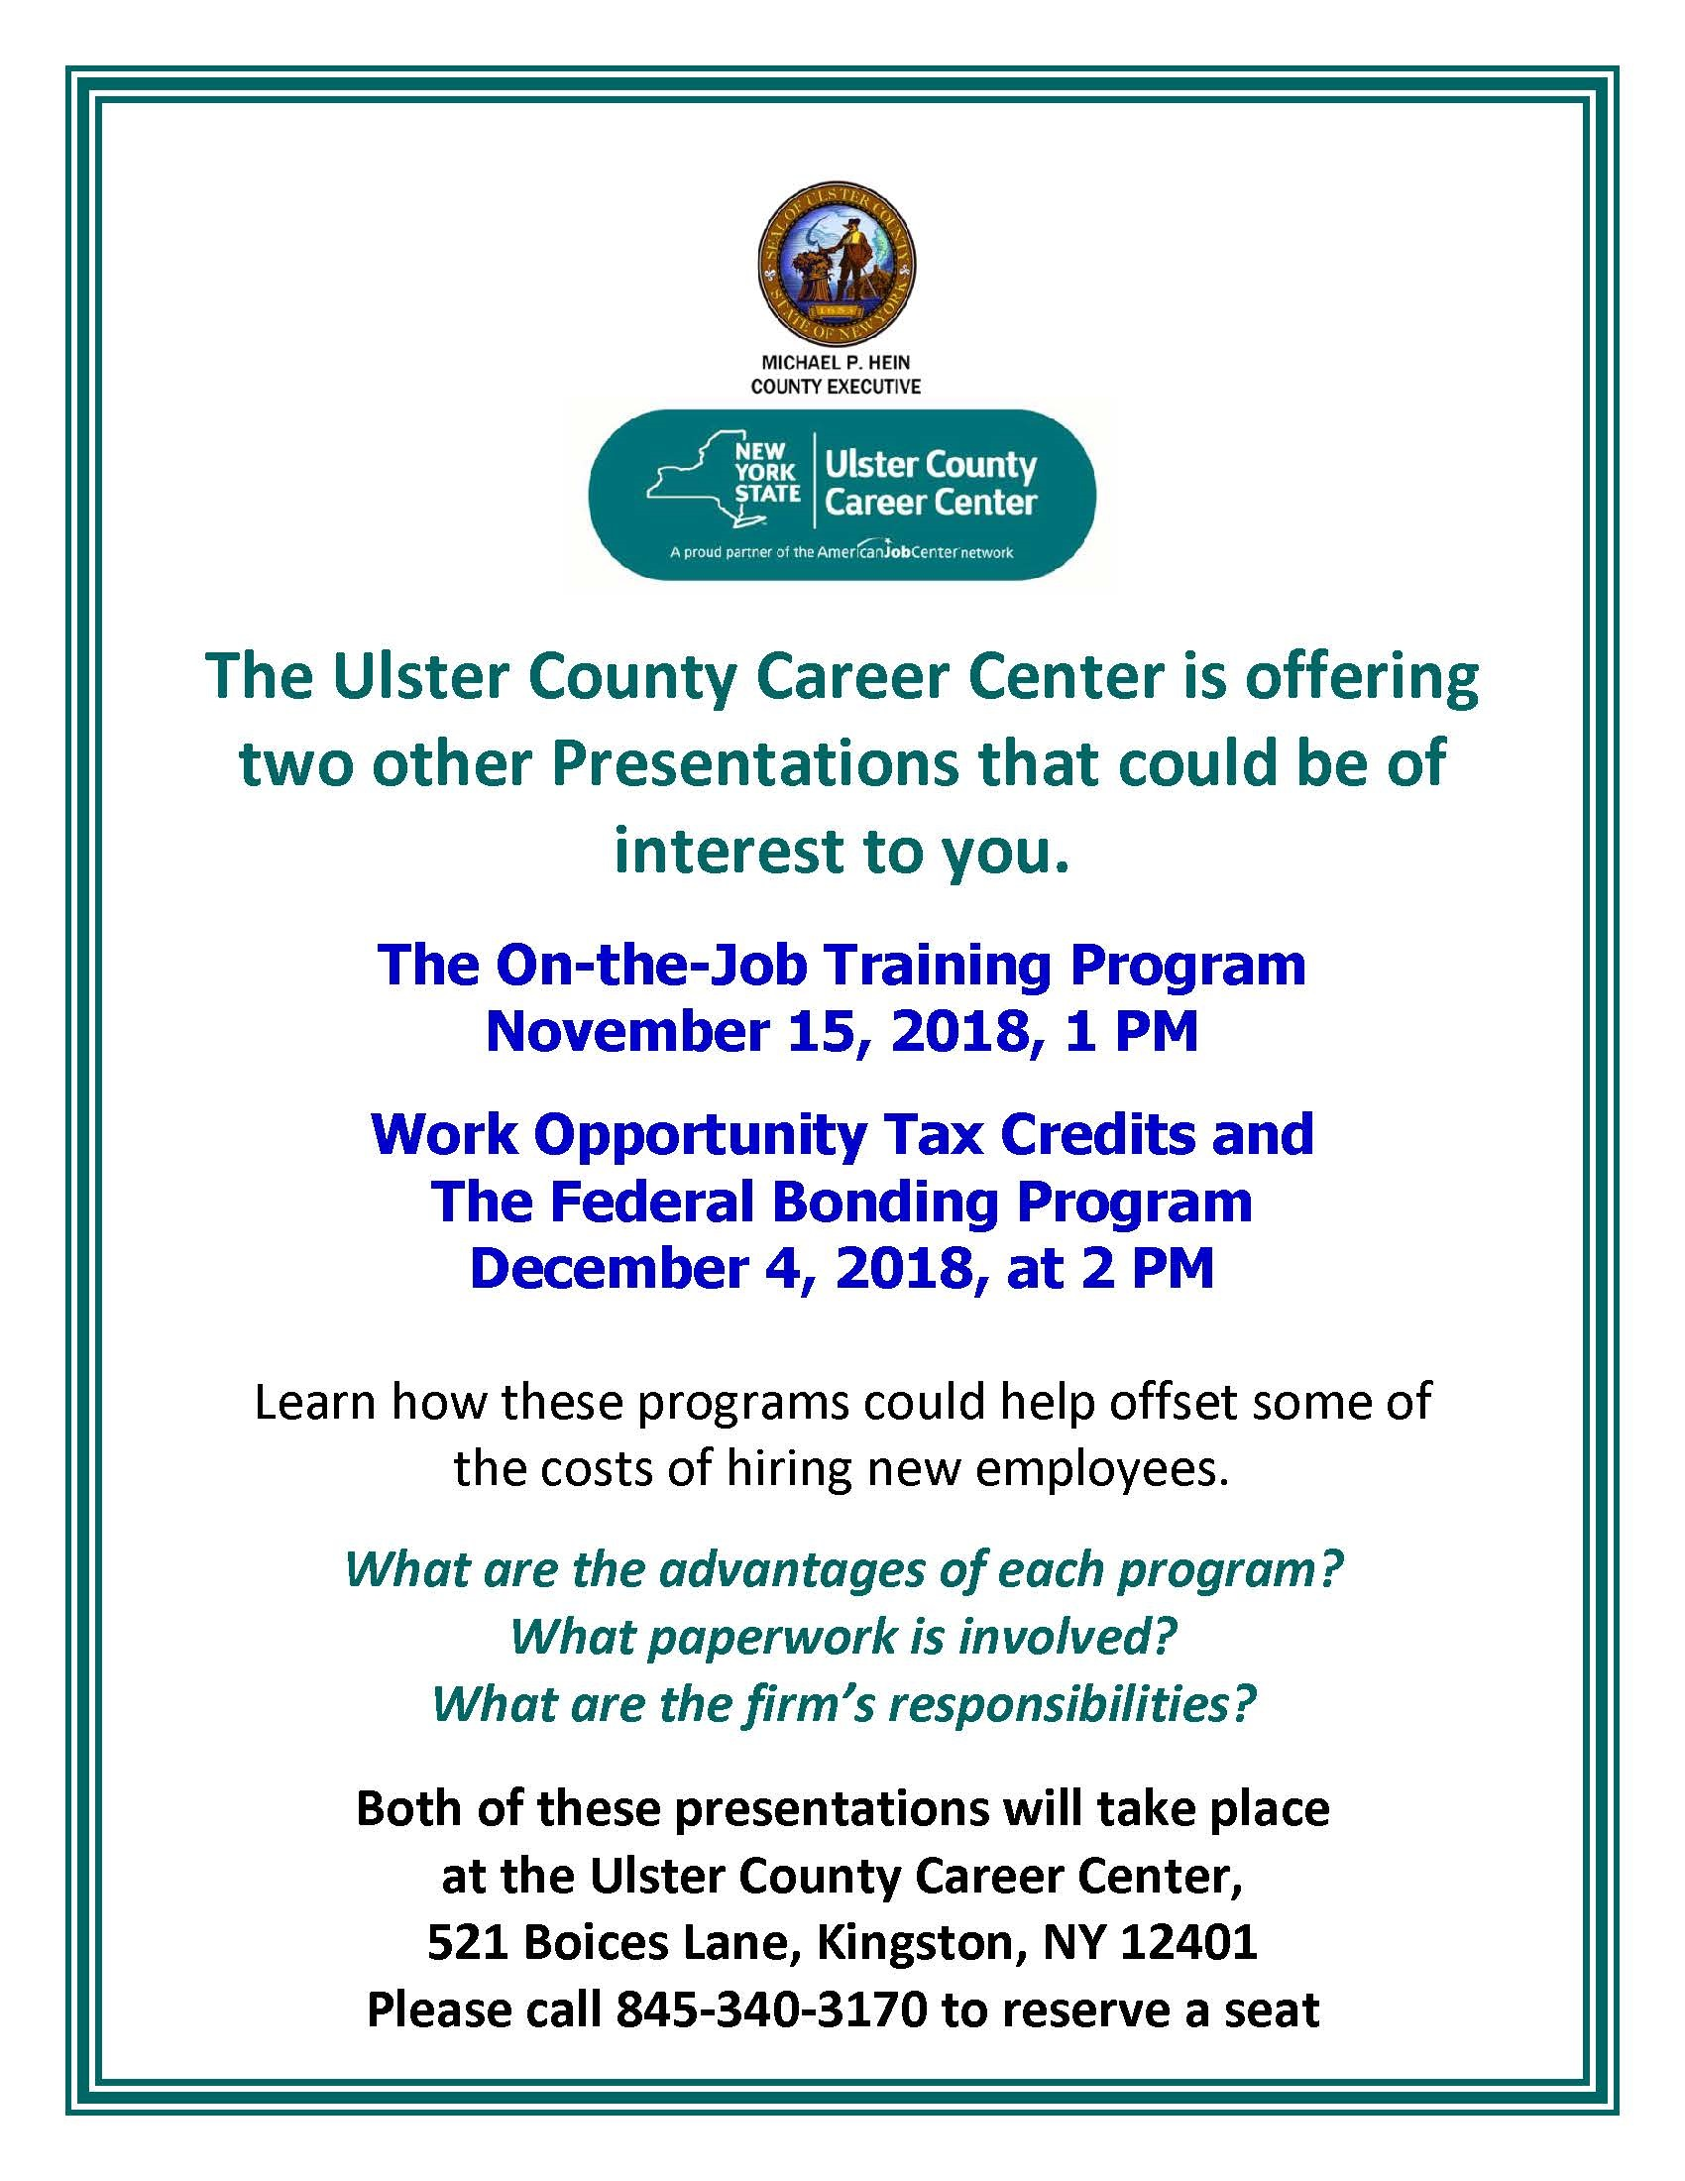

On December 4, The Ulster County Career Center is presenting a free workshop that may save your business money. Learn about Work Opportunity Tax Credits and The Federal Bonding Program. Reserve your seat today! Call (845) 340-3170. #UlsterForBusiness